

[Document title]

[Document subtitle]



[Date]

[Company name]

[Company address]

Contents

List of Figure 2

Problem 57.1.1 3

Code 3

Output 4

Problem 57.1.2 4

A) 4

Code 4

Output 6

B) 6

Code 6

Output 7

Problem 57.2.2 7

Code 7

Output 7

Problem 57.3.5 7

Code 8

Output 8

Fibonacci Code 8

# List of Figure

Figure 1: Problem 5.1.1 4

Figure 2: Problem 5.1.2 Part A 6

Figure 3: Problem 5.1.2Part 2 7

Figure 4: Problem 5.2.2 9

Figure 5: Problem 5.3.5 10

# Problem 57.1.1

First hundred Fibonacci sequence numbers are computed using MATLAB function Fibonacci. The Ratio between adjoining numbers is computed the usage of for loop and required plots are proven in the Figure beneath:

## Code

clc

clear

close all

% Semilogy for first 100 fibonacci numbers

x=1:100;

y=[];

for i=1:length(x)

y=[y fibonacci(i)];

end

% Ratio of adjacent fibonacci numbers

Ratio=zeros(1,length(y)-1);

for i=1:length(y)-1

Ratio(i)=y(i+1)/y(i);

end

zf(1) = figure(1);clf

za(1) = axes;

semilogy(x,y,'--')

title('Log Plot of fib. Numbers')

xlabel('--->Number from 1 to 100')

ylabel('--->Log value of Fibonacci Number')

set(za(1),'position',[0.1 0.6 0.8 0.3])

za(2)=axes;

plot(Ratio,'--')

title('Ratio between fibonacci Numbers')

xlabel('--->Number from 1 to 100')

ylabel('--->Ratio value')

set(za(2),'position',[0.1 0.1 0.8 .3])

ss = ['p5711'];

figsize = [5 3.5];

set(zf(1),'papersize',figsize)

set(zf(1),'paperposition',[0 0 figsize]);

print(zf(1),'-dpng','-r300','-painters',ss)

## Output

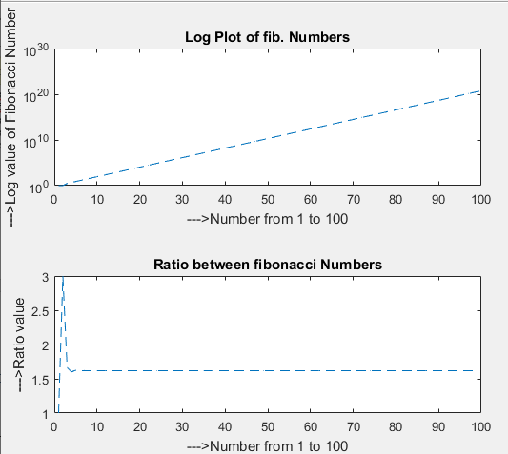

Figure 1: Problem 5.1.1

# Problem 57.1.2

## 

Plot results are shown in the Figure beneath including Line Plot, Semilogx, Semilogy and Loglog.

### Code

clear all

clc

close all

% Part 1

x1 = [.01:.1:100]';

m = 2;

b = [-1 0 1];

y = m*(x1*[1 1 1]) + (ones(length(x1),1)*b);

% zf(1) = figure(1);clf

% za(1) = axes

subplot(2,2,1)

plot(x1,y);

title('Line Plot')

xlabel('x')

ylabel('Line')

% set(za(1),'position',[.1 .6 .29 .29])

% za(2) = axes

subplot(2,2,2)

semilogx(x1,y);

title('Semilogx')

xlabel('x')

ylabel('Semilogx')

% set(za(2),'position',[.6 .6 .29 .29])

% za(3) = axes

subplot(2,2,3)

semilogy(x1,y);

title('Semilogy')

xlabel('x')

ylabel('Semilogy')

% set(za(3),'position',[.1 .18 .29 .29])

% za(4) = axes

subplot(2,2,4)

loglog(x1,y);

title('Loglog')

xlabel('x')

ylabel('Loglog')

% set(za(4),'position',[.6 .18 .29 .29])

### Output

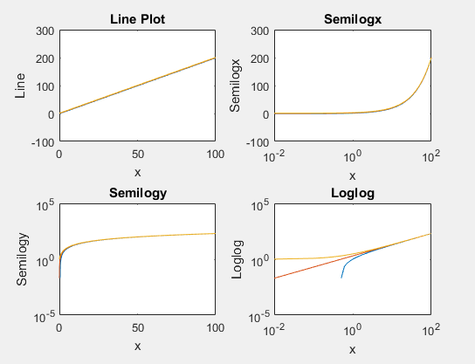

Figure 2: Problem 5.1.2 Part A

## 

The exponential feature produces straight line with Semilogy, and a logarithmic feature produces straight line for Semilogx plot as shown beneath in the Figure:

### Code

%Part2

y=exp(1:100);

y1=log10(1:100);

zf(2) = figure(2);clf

za(1) = axes;

semilogy(y,'o-','Color',[0 0 0])

title('Semilogy of Exponential')

ylabel('Semilogy')

set(za(1),'position',[0.1 0.6 0.8 0.3])

za(2)=axes;

semilogx(y1,'o-','Color',[0 0 0])

title('Semilogx of Log ')

ylabel('Semilogx')

set(za(2),'position',[0.1 0.1 0.8 .3])

ss = ['p5712_2'];

figsize = [5 3.5];

set(zf(2),'papersize',figsize)

set(zf(2),'paperposition',[0 0 figsize]);

print(zf(2),'-dpng','-r300','-painters',ss)

### Output

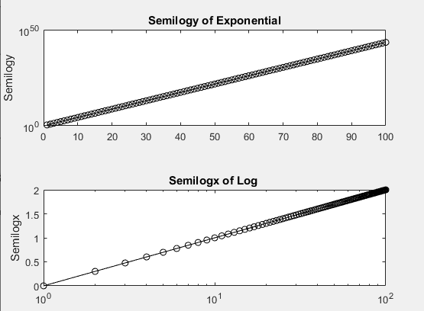

Figure 3: Problem 5.1.2Part 2

# Problem 57.2.2

The required graphs are plotted using extraordinary logarithmic plot functions such as semilogx, semilogy and loglog. The top outcomes are produced the use of semilogy and are proven beneath in Figure:

## Code

clc

clear all

close all

x=1:100;

y=[];

for i=1:length(x)

y=[y fibonacci(i)];

end

Ratio=zeros(1,length(y)-1);

for i=1:length(y)-1

Ratio(i)=y(i+1)/y(i);

end

zf(1) = figure(1);clf

za(1) = axes;

semilogy(y,'o')

title('first 100 number Fib Plot ')

xlabel('x')

ylabel('Fibnoacci Number ')

set(za(1),'position',[.1 .6 .29 .29])

za(2)=axes;

plot(Ratio,'o')

title('Ratio of fibonacci Numbers')

set(za(2),'position',[.6 .6 .29 .29])

xlabel('x')

ylabel('ratio')

P=primes(104729); %first 10000 prime numbers

Ratio1=zeros(1,length(P)-1);

for i=1:length(P)-1

Ratio1(i)=P(i+1)/P(i)-1;

end

za(3) = axes;

semilogy(P,'o');

title('1 to 10000 Primes Number')

xlabel('x')

ylabel('Primes Number ')

set(za(3),'position',[.1 .18 .29 .29])

za(4) = axes;

plot(Ratio1,'o');

title('Ratio of Primes Number ')

xlabel('x')

ylabel('ratio')

set(za(4),'position',[.6 .18 .29 .29])

ss = ['p5722'];

figsize = [5 3.5];

set(zf(1),'papersize',figsize)

set(zf(1),'paperposition',[0 0 figsize]);

print(zf(1),'-dpng','-r300','-painters',ss)

## Output

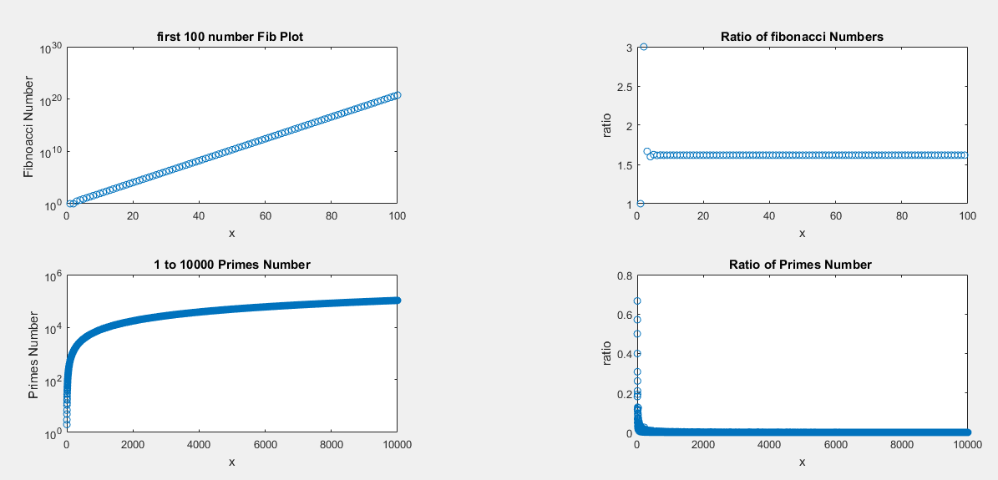

Figure 4: Problem 5.2.2

# Problem 57.3.5

All the required plots for the variables form are in the given data, it is all plotted as shown beneath in the figure indicating the unemployment rate, GDP growth rate and Inflation rate.

## Code

clear

clc

close all

load('unemployment_data.mat')

unemployment= cell2mat(data(:,2));

gdp=cell2mat(data(:,3));

inflation=cell2mat(data(:,4));

year=cell2mat(data(:,1));

zf(1)=figure; clf

plot(year,unemployment,'--',year,gdp,':',year,inflation,'*-')

xlabel('year')

legend('Unemployment Rate','GDP Growth Rate','Inflation Rate')

grid on

ylabel('Data')

ss = ['p5735'];

figsize = [5 3.5];

set(zf(1),'papersize',figsize)

set(zf(1),'paperposition',[0 0 figsize]);

print(zf(1),'-dpng','-r300','-painters',ss)

## Output

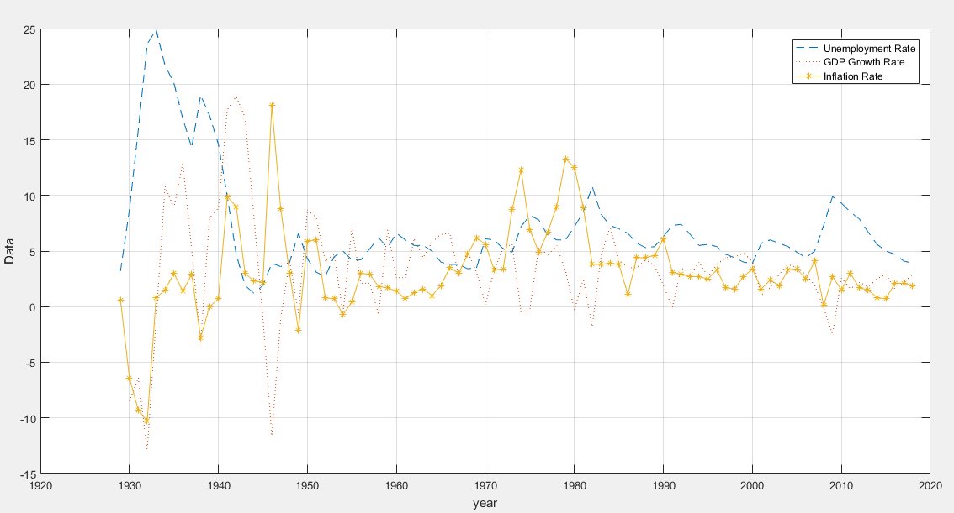

Figure 5: Problem 5.3.5

# Fibonacci Code

function x = fibonacci(n)

f(1)=1;

f(2) = 1;

for i=3:n

f(i) = f(i-1) + f(i-2);

end

if n>2

x=f(n-1)+f(n);

else

x=f(1);

end

end